User Manual:

Truckload Planning

| August-20 |

**Document Overview**

**Documentation Goals**

This documentation is intended to provide further instruction for ***Order Releases*** as they pertain to ***Carriers and Trucks*** for specified customers*.*

**Table of Contents**

**Overview of Advantzware Specific Keys and Icons** 2

Function Keys 2

Advanced Software Standard Function Keys 3

Program Icons 4

**Overview** 5

Release Codes 5

Status Code Summaries 5

**Order Entry** 6

Items Tab 6

Release Folder Tab 7

Actual Release Folder [OT1] 8

**Common Carrier** 9

Truck File 9

Truck Load Summary Worksheet 10

Truck Plan Selection 10

Truck Run Selection 11

Truck Load Business Form 11

# **Overview of Advantzware Specific Keys and Icons**

## Function Keys

|  |  |
| --- | --- |
| BRWS | The browser, which is a list of records in this file. This is functionally equivalent to the Find option of our standard package. |
| VIEW | View record provides the ability to ADD, CHANGE, DELETE, and UPDATE an individual record. |
| SORT BY | The selections at the bottom of the browser, which will sort the list alphabetic order. |
|  |  |
| Update | Update the current record. |
| Reset | Reset the current record. |
| Add | Add a record. |
| Copy | This will copy the existing record. |
| Delete | Delete the current record displayed on the screen. |
| Cancel | Cancel the information that was entered. |
| Save | Save the record. |
|  |  |
|  | Takes the user to the first current record. |
|  | Moves backward one record. |
|  | Moves forward one record. |
|  | Takes the user to the last current record. |
|  |  |
| F1 | Miscellaneous Fields |
| F3 | Search |
| F3 | List |
| F4 | Notes |
| F6 | Browse |
| F7 | Viewer |
| F12 | Exit |

## Advanced Software Standard Function Keys

|  |  |
| --- | --- |
| Next | Shows the next sequential record. |
| Prev | Shows the previous record. |
| Add | Add a record. |
| Change | Change the current record displayed on the screen. |
| Delete | Delete the current record displayed on the screen. |
| Find | Find a record by searching by description. |
| “1”, “2” | Number 1 or 2 to go the first or second page of this record. |
| Esc | Escape from the current transaction without updating. |
| Q | Quit from the current transaction without updating. |
| F1 | Save |
| F3 | Help information is available on every data field. Simply place the cursor on a field and press F3 to display documentation regarding this particular field. |
| F3 | To insert additional data in a data field without erasing the information currently displayed. |
| F4 | Notes – General |
| F1 | Field Lookup is available on every data field which is maintained in a separate file. Place the cursor on a field and press ***“F1”*** to search for the code by description or to advance a screen of records by pressing the next key. Place the cursor next to the desired record and press enter to transfer the record to the data entry screen. See ***“Page Up”*** / ***“Page Down”*** keys below as an alternative |
| F7 | Delete |
| F8 | Notes – File Specific |
| Enter | Advances the cursor to the next field |
| Page Up | Will skim forward through each record in a data file in sequential order |
| Page Down | Will skim backward through each record in a data file in sequential order |
|  |  |

## Program Icons

|  |  |  |
| --- | --- | --- |
|  | Job Notes |  |
|  | Customer Attachments | Attach files (such as Word/Excel/Images) for this specific customer order. |
|  | Change Move/Set Column Mode |  |
|  | Print Acknowledgement |  |
|  | Export to Excel |  |
|  | Add |  |
|  | Attachments | Attachments for this Estimate. Will transfer to all future repeat orders for this estimate. |
|  | Notes |  |
|  | Spec Notes | Notes for specific finished goods items. |
|  | Utility Application |  |
|  | Help |  |
|  | UDF Viewer |  |
|  | Commissions |  |
|  | Exit |  |
|  |  |  |
|  |  |  |

# **Overview**

## Release Codes

The first part of truck load planning is to understand the release status codes for each delivery. We like to refer to the *Release Folder* as the “*Scheduled*” Release Delivery Folder. Whereas the ***“O”-“T”-“1”*** screens are normally actual releases scheduled for delivery.

So, under this definition, the ***“O”-“U”-“1”***-Release Folder would have a future or planned delivery date, whereas ***“O”-“T”-“1”*** are releases which would normally ship within days. Scheduled releases may have multiple shipping locations, multiple dates and multiple purchase order numbers for the same item on an order.

Scheduled Release status codes may be ***“S”*** (Scheduled), ***“L”*** (Late), or ***“I”*** (Invoiceable).

Actual Release codes are ***“A”*** (Actual) or ***“B”*** (Backordered).

Once the actual release has posted, the status changes to ***“P”*** (Posted) and normally is found in the bill of lading file. Once the bill of lading is posted, the status changes to ***“Z”*** status for shipped complete and invoice created and is then found in the invoice file.

If the bill of lading is partially shipped, the partial quantity release will have a status of ***“B”*** (Backorder) and will be found in ***“O”-“T”-“1”***. When the invoice is posted, the release status changes to ***“C”***.

### Status Code Summaries

|  |  |  |
| --- | --- | --- |
| A | Actual | Actual release. Find in ***“O”-“T”-“1”*** Actual release file |
| B | Backorder | Bill of Lading Posted. Find partial release in ***“O”-“T”-“1”*** |
| C | Invoiced | Invoice Posted . Must find in inquiries or Invoiced Releases |
| I | Invoice Now | Invoice release. Date past Last Ship date in ***“O”-“U”-“1”*** Release Folder |
| L | Late | Late release. Current date past due date. Find in ***“O”-“U”-“1”*** Release Folder |
| P | Posted | Actual release Posted. Find in ***“O”-“S”-“1”*** bill of lading file |
| S | Scheduled | Scheduled release based on date. Find in ***“O”-“U”-“1”*** Release Folder |
| Z | Completed | Bill of Lading Posted. Find in ***“O”-“B”-“1”*** invoice file or invoice posted |

# **Order Entry**

## Items Tab

The *Order Maintenance* screen is located in the following Menu Path: Order Processing -> Update/Add Orders -> Order Entry. Alternatively, the user can quickly get to this screen using the Hot Key combination: ***[“O” – “U” – “1”]***.

The *Order Item Detail* screen is located on the *Items* tab. The user should first choose their selected order, then the desired item within that order. The user may then either ***“Double-Click”*** that item, or click on the ***“View”*** button at the bottom of the screen to bring up details about that specific item.

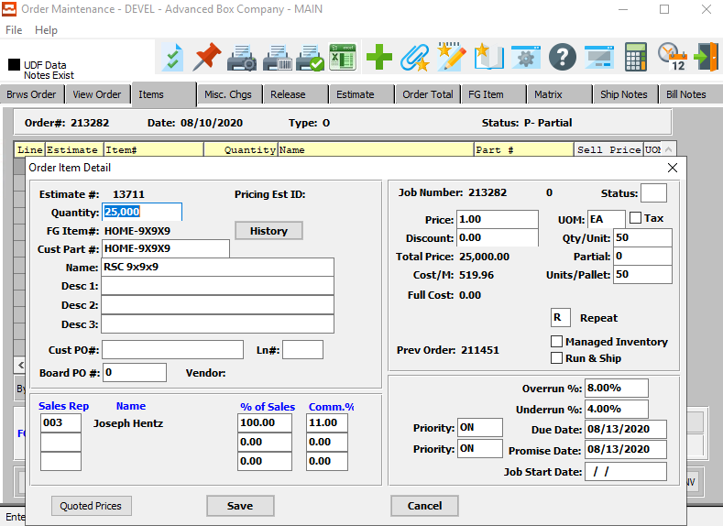

If a finished goods line item is added without an estimate, the count imports from the finished goods file. If the item is created from an estimate, the quantity per unit and units per pallet are transferred from the estimate.

Please Note: The unit may be a case, bundle or pallet count. If you ship by the pallet then the units per Pallet will be 1.

However, if you ship cases or bundles, then the units/Pallets will be how many cases or bundles per pallet. The counts are downloaded to the actual release if the user does not pick specific pallets tags for the delivery.

## Release Folder Tab

The *Order Maintenance* screen is located in the following Menu Path: Order Processing -> Update/Add Orders -> Order Entry. Alternatively, the user can quickly get to this screen using the Hot Key combination: ***[“O” – “U” – “1”]***.

The *Release* screen is located on the *Release* tab. The user should first choose their selected order, then the desired release within that order. The user may then either ***“Double-Click”*** that release, or click on the ***“View”*** button at the bottom of the screen to bring up details about that specific release.

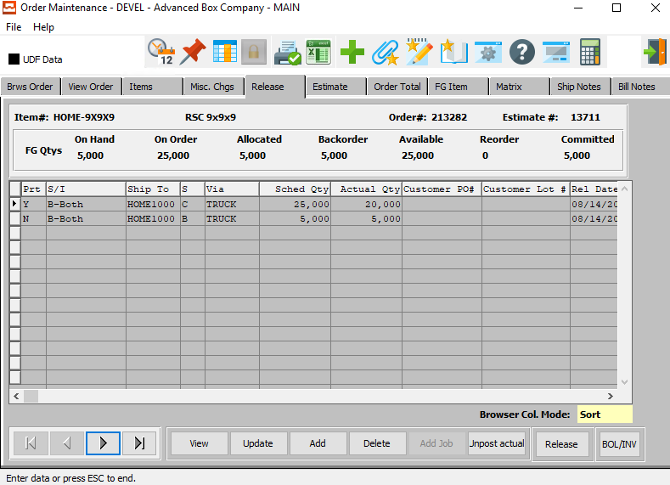

The Release folder allows changing the quantity for each release. The “***Release”*** Button provides the option to select specific pallet tags or just the release quantity without pallet tags.

If you select *(Pallet Tags)*, then the system knows the exact pallet numbers and total number of pallets. If you select *(No Tags)*, then once released, the quantity and pallet count are transferred from the Items folder.

Thus, the quantity divided by count will equal the number of pallets for the truck load summary report.

## Actual Release Folder [OT1]

The *Order Release* screen is located in the following Menu Path: Order Processing -> Tickets for Releases -> Enter/Edit Release. Alternatively, the user can quickly get to this screen using the Hot Key combination: ***[“O” – “T” – “1”]***.

The user may view detailed information about a selected release on the *Items* tab. The user may then either ***“Double-Click”*** that release, or click on the *Items* tab at the top of the screen to bring up details about that specific release.

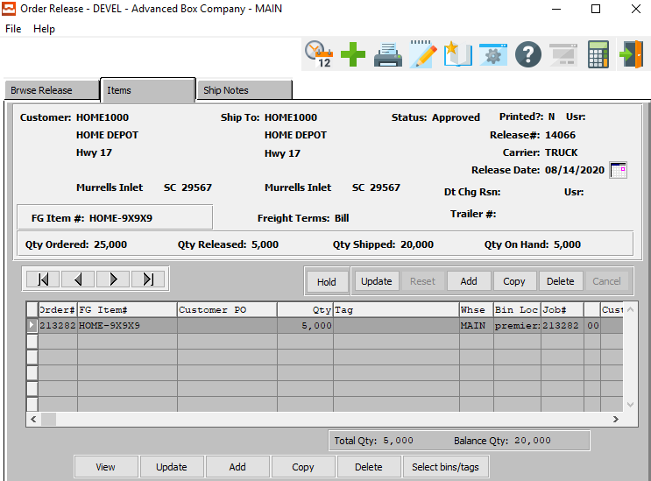

The Actual Release will display the total number of pallets for this delivery based on the release quantity. If specific pallet were chosen, then each line would have just 1 pallet. The total number of pallets for all lines will be downloaded to the truck summary program.

# **Common Carrier**

## Truck File

The *Common Carriers* screen is located in the following Menu Path: Accounts Receivable -> File Maintenance for Customers -> Truck/Common Carriers. Alternatively, the user can quickly get to this screen using the Hot Key combination: ***[“A” – “F” – “8”]***.

The *Truck* file is located on the *Truck* tab. The user should first choose their selected carrier, then the desired truck owned by that carrier. The user may click on their desired truck within the list of available options on the *Truck* screen to bring up details about that specific truck.

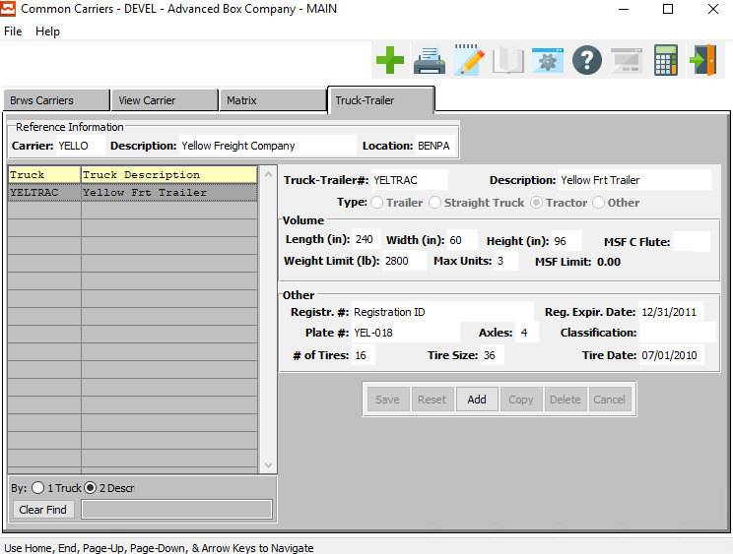

Each truck in the fleet must be defined in the Common Carrier/Truck file.

Each truck must have the capacity of size, pallets and MSF which will be used in the Truck Load Summary program.

## Truck Load Summary Worksheet

The truck load program allows you to select a specific release type within a specific date range, delivery zone, carrier and other criteria. Once selected, the program will list all the deliveries on a worksheet so that you can assign a truck, load number and stop number.

The program will provide a warning message if the number of pallets or square footage exceeds the trucks capacity set in the truck file. Once done, print the excel spreadsheet for each truck driver. The business form has columns for the driver to enter the time.

### Truck Plan Selection

The *Truck Plan Selection* screen is located in the following Menu Path: Order Processing -> Shipping/Bill of Lading -> Truck Plan Selection. Alternatively, the user can quickly get to this screen using the Hot Key combination: ***[“O” – “S” – “7”]***.

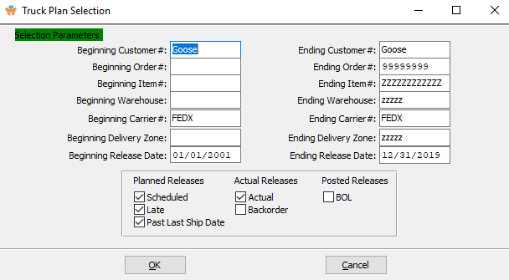

The user may now input their selection parameters as to which truck plans they wish to print. Multiple truck plans can be printed at the same time, as the user can enter the beginning and ending selections into their desired fields. Truck plans within those parameters will print details for the user.

The user may now take this opportunity to check any toggle boxes for other special rules that they wish the truck plans to follow. For any questions concerning specific rules, the user may refer to the ***“Order Processing Manual”***.

### Truck Run Selection

Once the user has made all selections to their satisfaction, they may click the ***“OK”*** button at the bottom of the screen. This will bring up the *Truck Run Selection* screen for their further review.

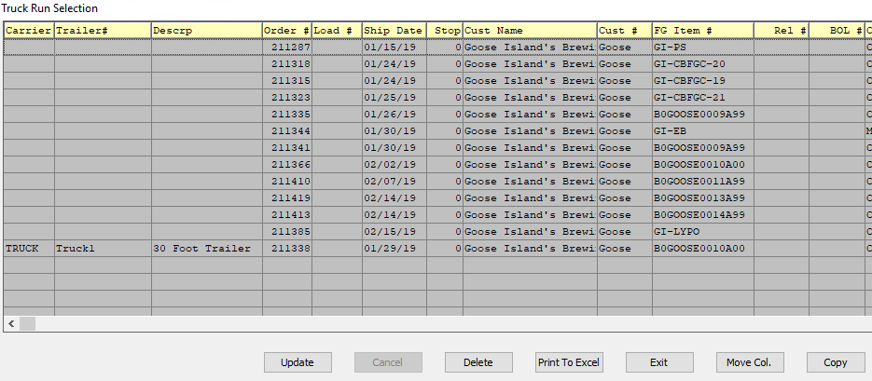

On this screen, the user may further decide which columns they wish to view on their printed report before finalizing. Once finished they may click the ***“Print to Excel”*** button on the bottom of the screen to export their selections to a printable Excel program.

### Truck Load Business Form

Once the user has printed their *Truck Plan* selections to the Excel program, they may view it a *Business Form* excel spreadsheet.

